Case Study 98: University Academic Progression Audit
1. Problem Statement
Combine semester marks, subject pass conditions, attendance and prerequisite completion records to determine whether students are eligible to progress to the next semester.
2. Objectives
Check each subject's pass mark.
Check attendance requirement.
Check prerequisite completion.
Report all reasons preventing progression.
3. Assumptions
Each subject mark is out of 100 and the pass mark is 40.
Minimum attendance is 75%.
All prerequisite subjects must be completed.
A student progresses only if all conditions are satisfied.
4. Algorithm
Read each student's subject marks, attendance and prerequisite status.
Check every subject mark.
Check attendance and prerequisite completion.
Collect all failure reasons.
Display progression eligibility and reasons.
5. Flowchart
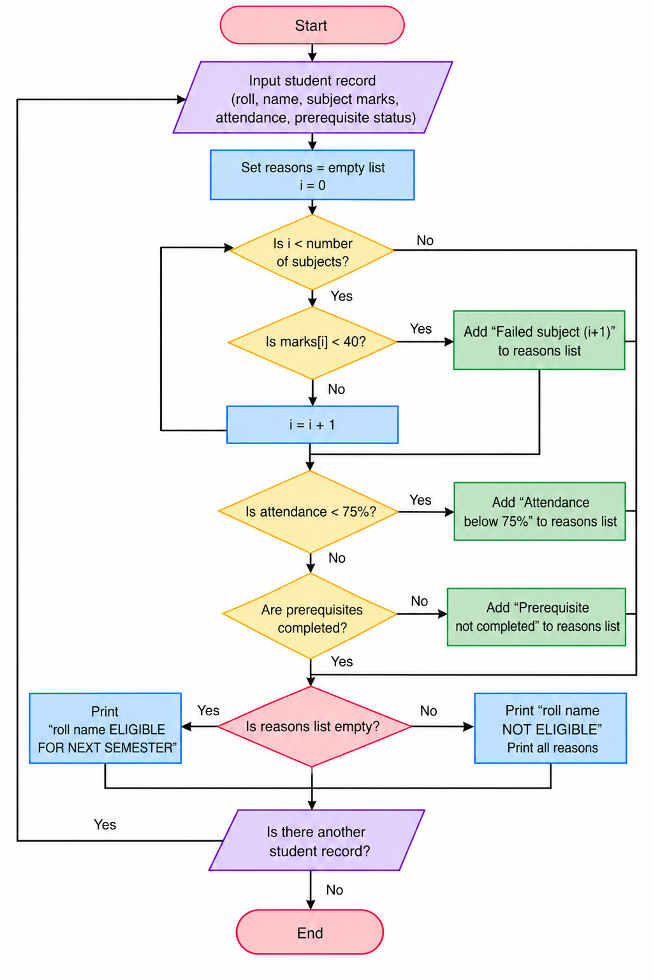
6. Pseudocode
START
Read each student's subject marks, attendance and prerequisite status.
Check every subject mark.
Check attendance and prerequisite completion.
Collect all failure reasons.
Display progression eligibility and reasons.
Display result
STOP
7. Test Cases
Input / Record | Expected Result
IT201 | Eligible for next semester
IT202 | Not eligible; failed subject 2
IT203 | Not eligible; attendance below 75%
IT204 | Not eligible; prerequisite incomplete
8.Output Screenshot
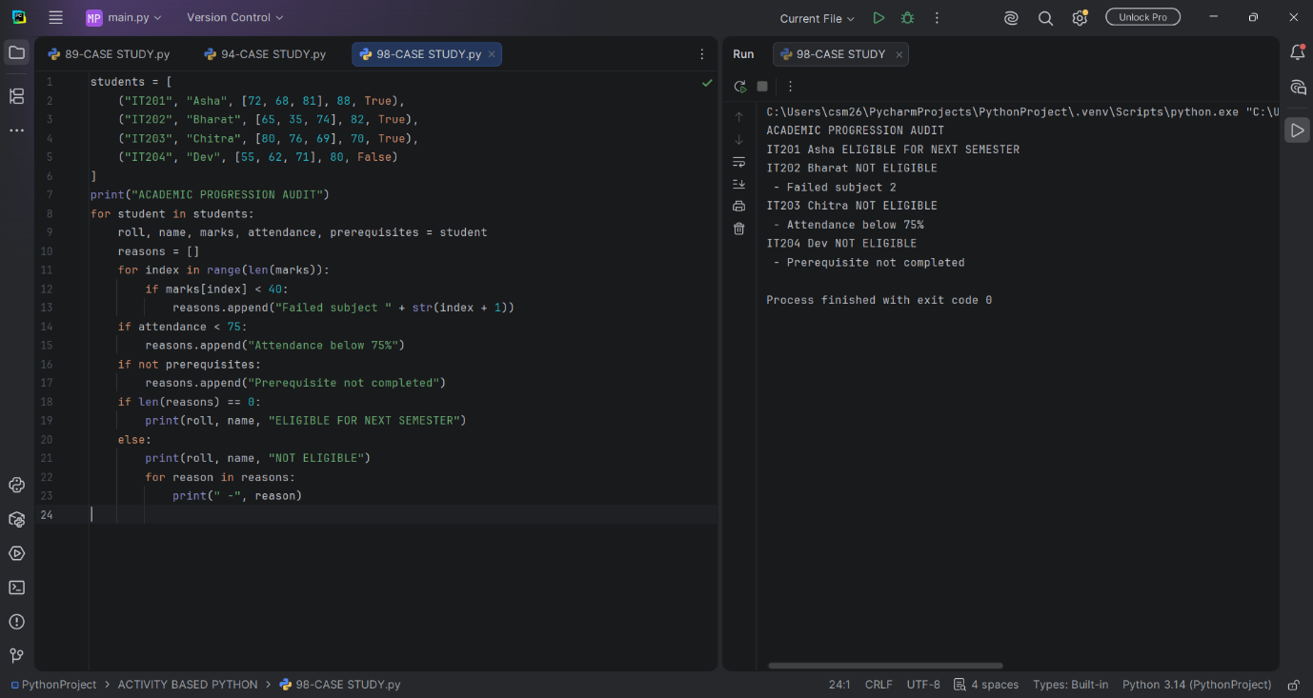
9. Conclusion
The program audits academic performance, attendance and prerequisite completion before deciding progression.

